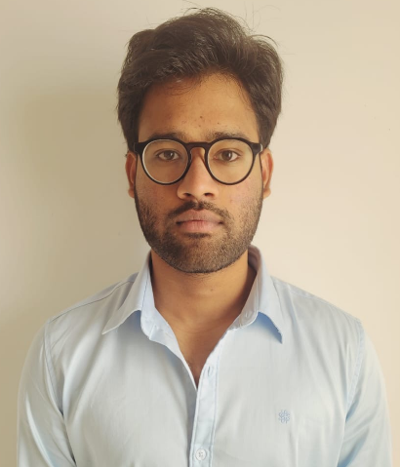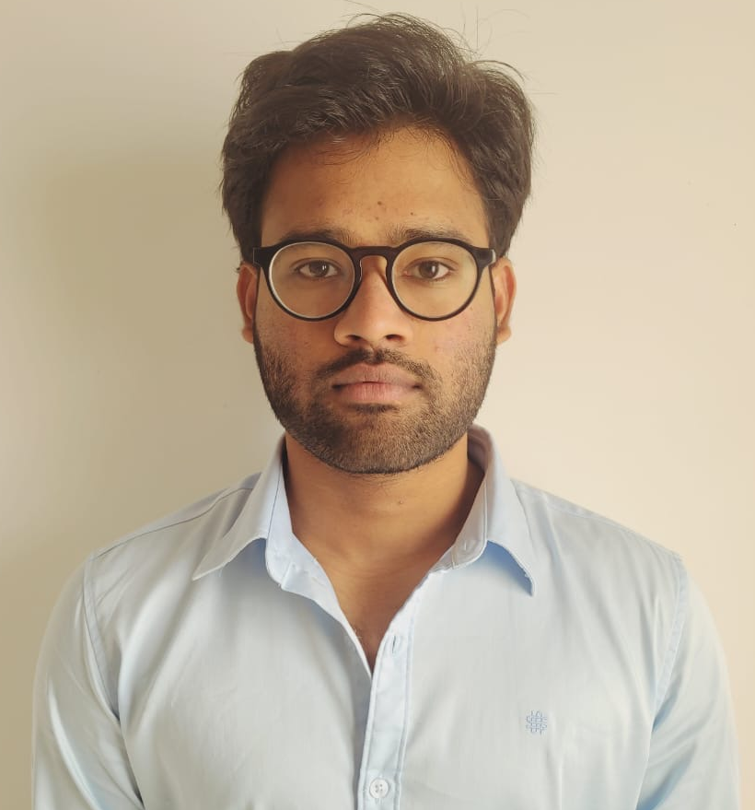

1

© Capgemini 2017. All rights reserved

|

Presentation Title | Author | Date



**Strengths**

**Achivement**

**Education**

**Base Location:**

**Email ID:**

**Mobile No:**

**Grade:**



**Hotel Management System Application**

Completed end to end case study of

Hotel Management

System a

long with Swagger and logger.

System

using

Spring boot with Angular as UI

.

.

**Certificates :**

*Agile Software Development

*AZ-900

*.net core

Analyst/Software Engineer

**Bangalore**

naveen-kumar.raseti@capgemini.com

+91

8374665518

•

A self driven learner with Front

-

End and Back

-

End

knowledge. Passionate about implementing and

launching new projects.

•

Ready to learn new technologies/Frameworks and

implement them to further improve my knowledge.

•

A team player with good communication skill always

ready to work for the enrichment of knowledge.

•

Has working knowledge on Angular and dot net core

Development on an Begginer level.

•

Also Implemented Spring Boot in our case study.

Bachelor of Technology

ECE – 2017-2021

**Skills**

C

C#

Azure

Angular

**Database**

SQL database

–

Postgres

**Web Technologies**

HTML5

CSS3

Bootstrap

JavaScript

**AddOns**

Github

Maven

Postman

**Additional Details**

Excellent Communication Skills

Team Player

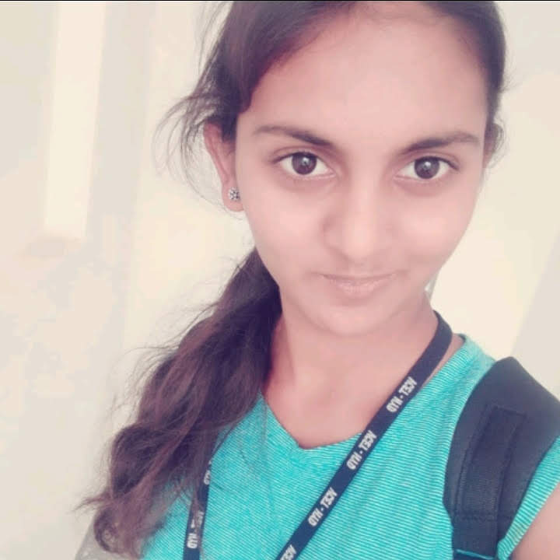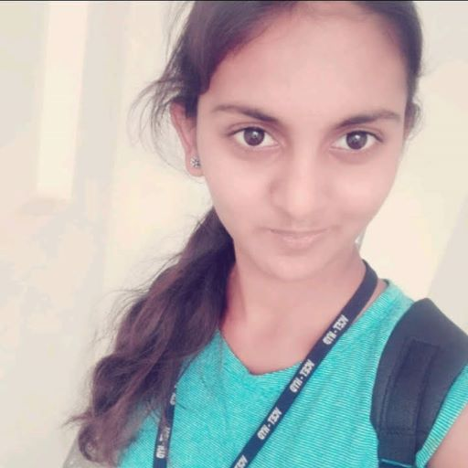

**Raseti,Naveen Kumar**



A4